### **A NOVEL METHOD FOR HANDWRITTEN** **DIGIT RECOGNITION SYSTEM**

Submitted By

TEAM ID : PNT2022TMID05849

Team Size : 4

Team Leader : Sandeesh S

Team Member : Sugesh Gowdharsan S J

Team Member : Praveen Kumar K

Team Member : Venkatkrishna S V

**TABLEOF CONTENTS**

|  |  |  |  |
| --- | --- | --- | --- |
|  | 1. **LAUNCHING** | **1** |  |
|  | 1.1 PROJECT OVERVIEW |  | 1 |
|  | 1.2 PURPOSE |  | 1 |
|  | **2 LITERATURE SURVEY** |  | **2** |
|  | 2.1 EXISTING PROBLEM |  | 2 |
|  | 2.2 mention |  | 2 |
|  | 2.3 PROBLEM STATEMENT DEFINITION |  | 5 |
|  | **3 IDEATION AND PROPOSED SOLUTION** |  | **6** |
|  | 3.1 EMPATHY MAP CANVAS |  | 6 |
|  | 3.2 IDEATION & BRAINSTORMING |  | 7 |
|  | 3.3 PROPOSED SOLUTION |  | 8 |
|  | 3.4 PROBLEM SOLUTION FIT |  | 9 |
|  | **4 REQUIREMENT ANALYSIS** |  | **10** |
|  | 4.1 FUNCTIONAL demand |  | 10 |
|  | 4.2 NON FUNCTIONAL demand |  | 11 |
|  | **5 PROJECTDESIGN** |  | **12** |
|  | 5.1 DATA FLOW DIAGRAM |  | 12 |
|  | 5.2 SOLUTION & TECHNICAL ARCHITECTURE |  | 13 |
|  | 5.3 USER STORIES |  | 15 |

|  |  |  |  |
| --- | --- | --- | --- |
|  | **6. PROJECTPLANNING AND SCHEDULING** |  | **16** |
|  | 6.1 SPRINT PLANNING AND estimate |  | 16 |
|  | 6.2 SPRINT bringing SCHEDULE |  | 17 |
|  | **7. CODING& SOLUTIONING** |  | **1**8 |
|  | **8. TESTING** |  | **2**0 |
|  | 8.1 TEST CASES |  | 20 |
|  | 8.2 USER ACCEPTANCE TESTING |  | 22 |
|  | 8.3 DEFECT ANALYSIS |  | 22 |
|  | 8.4 TEST CASE ANALYSIS |  | 22 |
|  | **9 RESULTS** |  | **2**3 |
|  | 9.1 PERFORMANCE METRICS |  | 23 |
|  | **10 reward &DISADVANTAGES** |  | **2**5 |
|  | 10.1 vantage |  | 25 |
|  | 10.2 disfavor |  | 25 |
|  | **11 CONCLUSION** |  | **2**6 |
|  | **12FUTURE SCOPE** |  | **27** |
|  | **APPENDIX** |  | **28** |
|  | SOURCE CODE |  | 28 |
|  | GITHUB |  | 37 |
|  | PROJECT DEMO |  | 37 |

**CHAPTER 1**

**LAUNCHING**

* 1. **PROJECT OVERVIEW**

Machine learning , deep learning play an important role in computer applied science and artiﬁcialintelligence. With the use of deep learning, machine learningcan be reduced in recognize, predictions and in many more areas.

Handwritten Digit Recognition is the ability of computer systems to recognize handwritten digits from various sources, such as images, documents, among other examples. This projectaims to let users take advantage of machine learning to reduce manual tasks in recognize digits.

* 1. **PURPOSE**

Digit recognition systems are capable of recognizing the digits from different sourceslike emails,bank quench,papers,images, etc. and in different real-world scenarios for online handwriting recognition on computer tablets or system, recognize number plates of vehicles, processing bank quench amounts, numeric entriesin forms ﬁlled up by hand (tax forms) and so on.

**CHAPTER 2**

**LITERATURE SURVEY**

* 1. EXISTING PROBLEM

The fundamental problem with handwritten digit recognition is that handwritten digits do not always have the same size, width, orientation, and margins since they vary from person to person. Additionally, there would be issues with identifying the numbers because of similarities between numerals like 1 and 7, 5 and 6, 3 and 8, 2 and 5, 2 and 7, etc. Finally, the individuality and variation of each individual's handwriting inﬂuence the structureand appearance of the digits.

* 1. REFERENCES

**Improved Handwritten Digit Recognition Using Convolution Neural Networks (CNN)(2020)**

*Hiawatha, Savita and Choudhary,Amit and Nayyar,Anand and Singh, Saurabh and Yoon,Burgundy*

This paper's primary goal was to enhance handwritten digit recognition ability. To avoiddifﬁcult pre-processing, expensive featureextraction, and a complex

ensemble (classiﬁer combination) method of a standard recognition system, they examined different convolution neural network variations. Their current work makes suggestions on the function of several hyper-parameters throughthorough evaluation utilizingan MNIST dataset.They also conﬁrmed that optimizing

hyper-parameters is crucial for enhancing CNN architecture performance. With the Adam optimizer for the MNIST database,they were able to surpass many previously published results with a recognition rate of 99.89%. it is made through the trials.

abundantly evident how the performance of handwritten digit recognition is affected by the number of convolution layers in CNN architecture. According to the paper, evolutionary algorithms can be explored for optimizing convolution ﬁlter kernel sizes, CNN learning parameters, and the quantity of layers and learning rates.

**AnEfﬁcient And ImprovedScheme For Handwritten Digit Recognition BasedOnConvolution Neural Network (2019)**

*Ali, Saqib and Shaukat, Sheehan and Azeem, Muhammad and Sakha-Wat,Zairen and Mahmood, Tariq and others*

This study uses rectiﬁed linear units (ReLU) activation and a convolution neural network (CNN) that incorporates the Deeplearning4j (DL4J) architecture to recognize handwritten digits. The proposed CNN framework has all the necessary parameters for a high level of MNIST digit classiﬁcation accuracy. The system's training takes into account the time factor as well. The system is also tested by altering the number of CNN layers for additional accuracyveriﬁcation. It is important to note that the CNN architecture consistsof two convolution layers,the ﬁrst with 32 ﬁlters and a 5x5 window size and the second with 64 ﬁlters and a 7x7 window size. In comparison to earlier proposed systems, the experimental ﬁndingsshow lathe proposed CNN architecture for the MNIST dataset demonstrates great performance in terms of time and accuracy. As a result, handwritten numbers are detected with a recognition rate of 99.89% and high precision (99.21%) in a short amountof time.

**Improved Handwritten Digit Recognition Using Quantum K-NearestNeighbor Algorithm (2019)**

*Wang, Xinjiangand Wang, Ruin and Li, Dong fen and Ada-Gyamﬁ, Daniel and Ti an, Kaitlin and Zhukov, Yin*

The KNN classical machine learning technique is used in this research to enable quantum parallel computing and superposition. They used the KNN algorithm with quantum acceleration to enhance handwritten digit recognition. When dealing with more complicated and sizable handwritten digital data sets,their suggested method considerably lowered the computational time complexity of the traditional KNN algorithm. The paper offered a theoretical investigation of how quantum concepts can be applied to machine learning. Finally, they established a fundamental operational conceptand procedure for machinelearning with quantum acceleration.

**Handwritten Digit Recognition Using Machine And Deep**  **LearningAlgorithms (2021)**

*Pa shine, Samay and Dixit, Ritikand Kushwah, Rishika*

In this study, they developed three deep and machine learning-based models for handwritten digit recognition using MNIST datasets. To determine which model was the most accurate, they compared them based on their properties.

Support vector machines are among the simplest classiﬁers, making them faster than other algorithms and providing the highest training accuracy rate in this situation. However,due to their simplicity, SVMs cannot categorize complicated and ambiguous images as accurately as MLP and CNN algorithms can. In their research, they discovered that CNN produced the most precise outcomes for handwritten digit recognition. This led them to the conclusion that CNN is the most effective

solution for all types of prediction issues, including those using picture data. By comparing the execution times of the algorithms, they determined that increasing the number of epochs without changing the conﬁguration of the algorithm is pointless. Due to the limit of a certain model and they discovered that beyond a certain number of epochs,the model beginsover-ﬁtting the dataset and provides biased predictions.

* 1. PROBLEM STATEMENT DEFINITION

For years,the trafﬁcdepartment has been combatingtrafﬁc law violators.

These offenders endanger not only their own lives, but also the lives of other individuals. Punishing these offenders is critical to ensuring that others do not become like them. Identiﬁcation of these offenders is next to impossible because for the average individual to write down the license plate of a recklessdriver. Therefore, the goal of this project is to help the trafﬁc department identify these offendersand reduce trafﬁc violations as a result.

**CHAPTER 3**

**IDEATION AND PROPOSEDSOLUTION**

**3.1 EMPATHY MAP CANVAS**

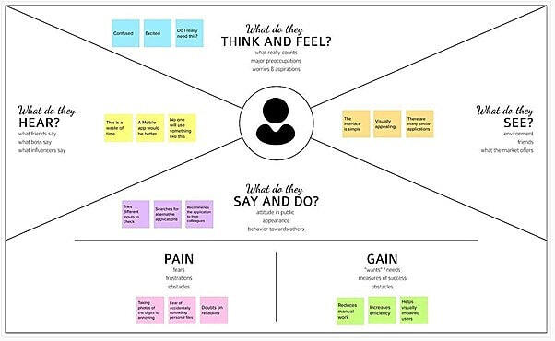

**3.2 IDEATION & BRAINSTORMING**

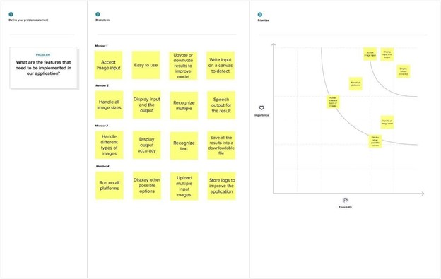

**3.3 PROPOSED SOLUTION**

|  |  |  |
| --- | --- | --- |
| **S.NO** | **PARAMETER** | **DESCRIPTION** |
| 1 | Problem Statement | To create an application thatrecognizes handwritten digits |
| 2 | Idea / Solution Description | The application takes an imageas the input and accurately detects the digits in it. |
| 3 | Novelty / Uniqueness | Instead of recognizing every text, the application accurately recognizes only the digits |
| 4 | Social Impact / CustomerSatisfaction | This application reduces the manual tasks that need to be performed. This improves productivity in the workplace. |
| 5 | Business Model | The application can be integrated with traffic surveillance cameras to recognize vehicle number plates    The application can be integrated with Postal systems to recognize the pin codes effectively |
| 6 | Scalability of the Solution | The application can easily bescaled to accept multiple inputs and process them parallel toincrease efficiency further |

**3.4 PROBLEMSOLUTIONFIT**

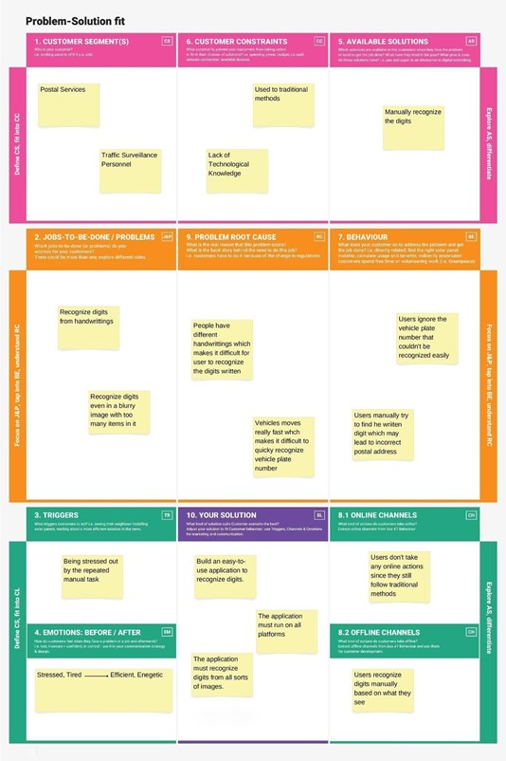

**CHAPTER 4**

**REQUIREMENT ANALYSIS**

**4.1 FUNCTIONAL REQUIREMENTS**

|  |  |  |
| --- | --- | --- |
| **FR.NO** | **FUNCTIONAL REQUIREMENTS** | **SUB REQUIREMENTS** |
| FR-1 | Model Creation | Get access the MNIST dataset |
| Analyze the dataset |
| Deﬁne a CNN model |
| Train and Test the Model |
| FR-2 | Application Development | Create a website to let the user recognize handwritten digits. |
| Create a homepage to upload images |
| Create a result page to display the results |
| Host the website to let the users use it from anywhere |
| FR-3 | Input Image Upload | Let usersupload images of various formats. |
| Let users upload images of varioussize |
| Prevent usersfrom uploading unsupported image formats |
| Pre-Process the image to use it on the model |

|  |  |  |
| --- | --- | --- |
|  |  | Create a database to store all the input images |
| FR-4 | Display Results | Display the result from the model |
| Display input image |
| Display accuracy the result |
| Display other possible predictions with the irrespective accuracy |

**4.2 NON FUNCTIONAL REQUIREMENTS**

|  |  |  |
| --- | --- | --- |
| **NFR** | **NON-FUNCTIONAL REQUIREMENTS** | **DESCRIPTION** |
| NFR-1 | Usability | The application must be usable in all devices |
| NFR-2 | protection | The application must protect user uploaded image |
| NFR-3 | Reliability | The application must give an accurate result as much as possible |
| NFR-4 | Performance | The application must be fast and quick to load up |
| NFR-5 | handiness | The application must be available to use all the time |
| NFR-6 | Scalability | The application mustscale along withthe user base |

**CHAPTER 5**

**PROJECT DESIGN**

**5.1 DATA FLOW DIAGRAM**

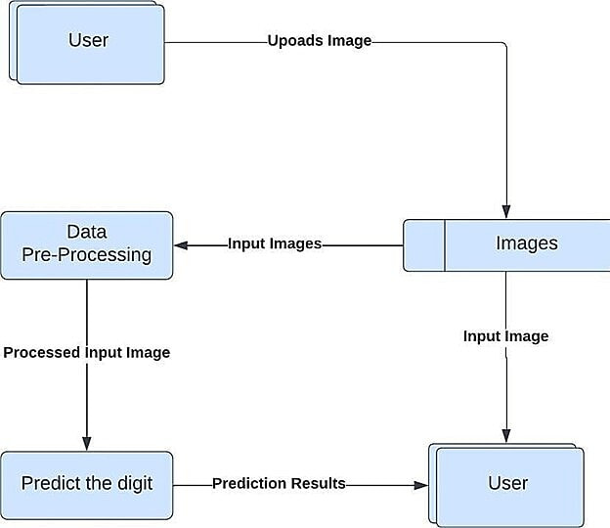

**5.2 SOLUTION & TECHNICAL ARCHITECTURE**

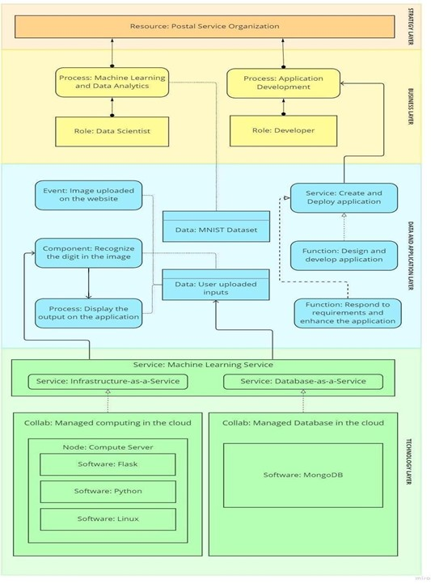

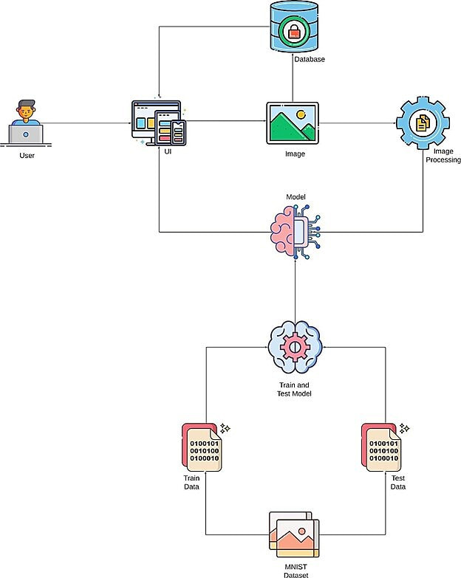

**5.3 USER STORIES**

|  |  |  |  |  |  |  |
| --- | --- | --- | --- | --- | --- | --- |
| User Type | Functional Requirements | User Story Number | User Story / Task | Acceptance Criteria | Priority | Release |
| Customer | Accessing the Application | USN-1 | As a user, I should be able to access the application from anywhere and use on any devices | User can access the application usingthe browser on any device | High | Sprint-4 |
| Uploading Image | USN-2 | As a user,I shouldbe able to upload images to predict the digits | User can upload images | High | Sprint-3 |
| Viewing the Results | USN-3 | As a user, I should be able to view the results | The result of the prediction is displayed | High | Sprint-3 |
| Viewing Other Prediction | USN-4 | As a user,I should be able to see other close predictions | The accuracy of other values must be displayed | Medium | Sprint-4 |
| Usage Instruction | USN-5 | As a user, I should have a usage instruction to know how to use the application | The usageinstruction is displayed on the home page | Medium | Sprint-4 |

**CHAPTER 6**

**PROJECT PLANNING AND SCHEDULING**

6.1 SPRINT PLANNING AND ESTIMATION

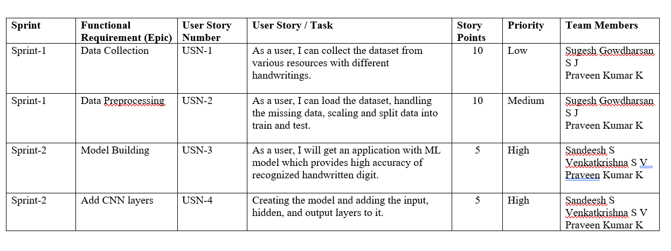

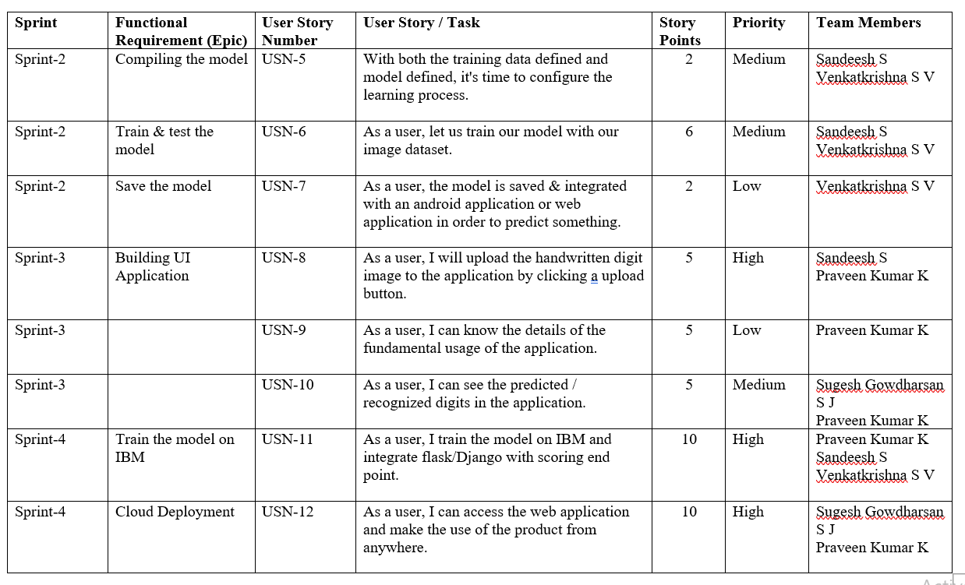

**6.2 SPRINT DELIVERYSCHEDULE**

|  |  |  |  |  |  |  |
| --- | --- | --- | --- | --- | --- | --- |
| **SPRINT** | **TOTAL STORY POINTS** | **DURATION** | **SPRINT STARTDATE** | **SPRINT END DATE (PLANNED)** | **STORY POINTSCOMPLETED (AS ON PLANNED DATE)** | **SPRINT RELEASEDATE (ACTUAL)** |
| Sprint - I | 11 | 6 Days | 24 Oct  2022 | 29 Oct  2022 | 11 | 29 Oct  2022 |
| Sprint - II | 9 | 6 Days | 31 Oct  2022 | 05 Nov  2022 | 9 | 05 Nov  2022 |
| Sprint - III | 10 | 6 Days | 07 Oct  2022 | 12 Nov  2022 | 10 | 12 Nov  2022 |
| Sprint - IV | 9 | 6 Days | 14 Nov  2022 | 19 Nov 2022 | 9 | 19 Nov 2022 |

**CHAPTER 7**

**CODING & SOLUTIONING**

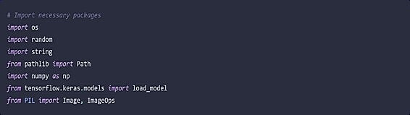

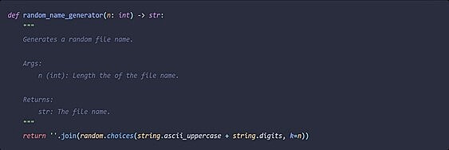

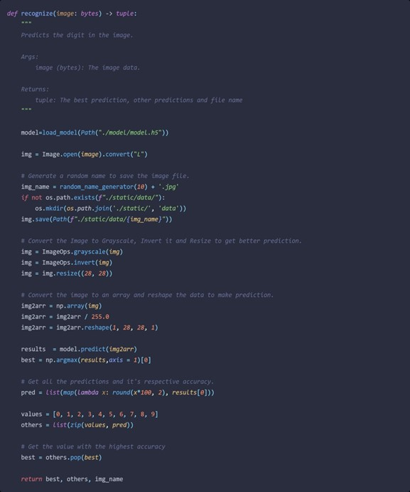

**CHAPTER 8**

**TESTING**

**8.1 TEST CASES**

|  |  |  |  |  |  |  |
| --- | --- | --- | --- | --- | --- | --- |
| **Test case ID** | **Feature Type** | **Component** | **Test Scenario** | **Expected Result** | **ActualResult** | **Status** |
| HP_TC_001 | UI | Home Page | Verify UI elements in the Home Page | The Home page must be displayed properly | Working as expected | PASS |
| HP_TC_002 | UI | Home Page | Check if the UI elements are displayed properly in different screen sizes | The Home page must be displayed properly in all sizes | The UI is not displayed properly in screen size 2560 x 1801  and 768 x 630 | FAIL |
| HP_TC_003 | Functional | Home Page | Check if user can upload their ﬁle | The input imageshould be uploaded to the application successfully | Working as expected | PASS |
| HP_TC_004 | Functional | Home Page | Check if user cannot upload unsupported ﬁles | The application should not allow user to select anon image ﬁle | User is able to upload any ﬁle | FAIL |
| HP_TC_005 | Functional | Home Page | Check if the page redirects to the result page once the input is given | The page should redirect to the results page | Working as expected | PASS |

|  |  |  |  |  |  |  |
| --- | --- | --- | --- | --- | --- | --- |
| BE_TC_001 | Functional | Backend | Check if all the routes are working properly | All the routes should properly work | Working as expected | PASS |
| M_TC_001 | Functional | Model | Check if the model can handlevarious image sizes | The model should re scale the imageand predict the results | Working as expected | PASS |
| M_TC_002 | Functional | Model | Check if the model predicts the digit | The model should predict the number | Working as expected | PASS |
| M_TC_003 | Functional | Model | Check if the model can handle complex input image | The model should predict the number in the complex image | The model fails to identify the digit since the model is not built to handle such data | FAIL |
| RP_TC_001 | UI | Result Page | Verify UI elements in the Result Page | The Result page mustbe displayed properly | Working as expected | PASS |
| RP_TC_002 | UI | Result Page | Check if the input image is displayed properly | The input image should be displayed properly | The size of the input image exceeds the display container | FAIL |
| RP_TC_003 | UI | Result Page | Check if the result is displayed properly | The result should be displayed properly | Working as expected | PASS |
| RP_TC_004 | UI | Result Page | Check if the other predictions are displayed properly | The other predictions should be displayed properly | Working as expected | PASS |

**8.2 USER ACCEPTANCE TESTING**

**8.2.1 DEFECT ANALYSIS**

|  |  |  |  |  |  |
| --- | --- | --- | --- | --- | --- |
| Resolution | Severity 1 | Severity 2 | Severity 3 | Severity 4 | Total |
| By Design | 1 | 0 | 1 | 0 | 2 |
| Duplicate | 0 | 0 | 0 | 0 | 0 |
| External | 0 | 0 | 2 | 0 | 2 |
| Fixed | 4 | 1 | 0 | 1 | 6 |
| Not Reproduced | 0 | 0 | 0 | 1 | 1 |
| Skipped | 0 | 0 | 0 | 1 | 1 |
| Won’t Fix | 1 | 0 | 1 | 0 | 2 |
| Total | 6 | 1 | 4 | 3 | 14 |

**8.2.2 TEST CASE ANALYSIS**

|  |  |  |  |  |
| --- | --- | --- | --- | --- |
| Section | Total Cases | Not Tested | Fail | Pass |
| Client Application | 10 | 0 | 3 | 7 |
| Security | 2 | 0 | 1 | 1 |
| Performance | 3 | 0 | 1 | 2 |
| Exception Reporting | 2 | 0 | 0 | 2 |

**CHAPTER 9**

**RESULTS**

9.1 PERFORMANCE METRICS

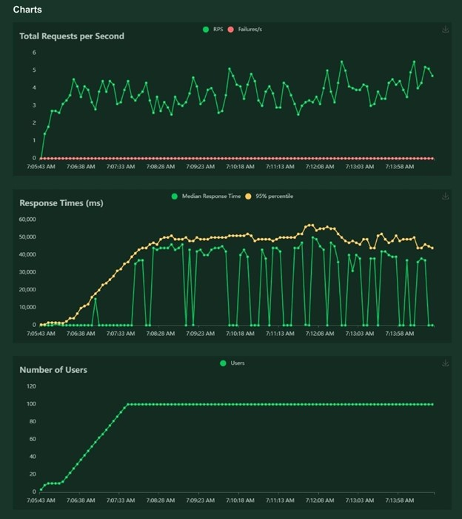

**CHAPTER 10**

**ADVANTAGES & DISADVANTAGES**

**ADVANTAGES**

* + 1. Reduces manualwork
    2. More accuratethan average human
    3. Capable of handling a lot of data
    4. Can be used anywherefrom any device

**DISADVANTAGES**

* + 1. Cannot handlecomplex data
    2. All the data must be in digital format
    3. Requires a high performance server for faster predictions
    4. Prone to occasional errors

**CHAPTER 11**

**CONCLUSION**

This project demonstrated a web application that uses machine learning to recognize handwritten numbers. Flask, HTML, CSS, JavaScript, and a few other technologies were used to create this project. The model predicts the handwritten digit using a CNN network. During testing, the model achieved a 99.61% recognition rate. The proposed project is scalable and can easily handle a huge numberof users. Since it is a web application, it is compatible with any device that can run a browser. This project is useful in real-world scenarios such as recognizing number plates of vehicles, processing bank quench amounts, numeric entries in forms ﬁlledup by hand (tax forms) and so on. There is so much room for improvement, whichcan be implemented in subsequent versions.

**CHAPTER 12**

**FUTURE SCOPE**

This project is far from complete and there is a substantial amount of room for improvement.

Some of the improvements that can be made to this project are as follows:

1. Add support to detect from digits multiple images and save the results
2. Add support to detect multiple digits
3. Improve model to detect digits from complex images
4. Add support to different languages to help users from all over the world

This project has endlesspotential and can always be enhanced to become better.Implementing this concept in the real world will beneﬁt several industries and reduce the workloadon many workers,enhancing overall work efﬁciency.

**APPENDIX**

**SOURCE CODE**

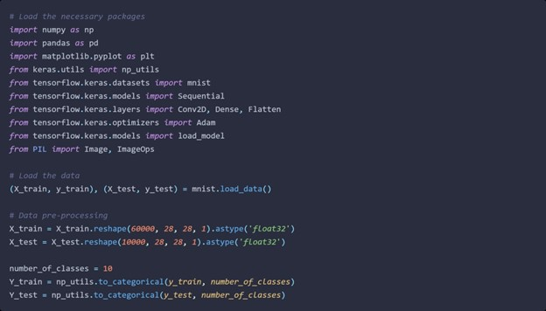

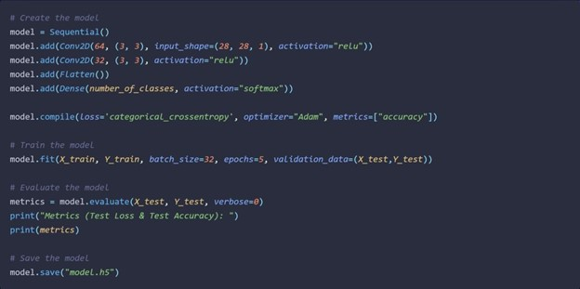

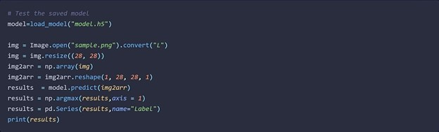

**FLASK APP**

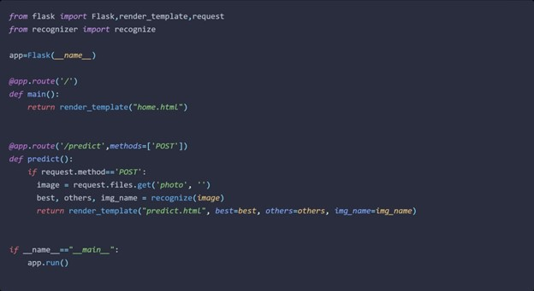

**RECOGNIZOR**

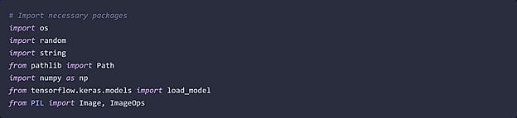

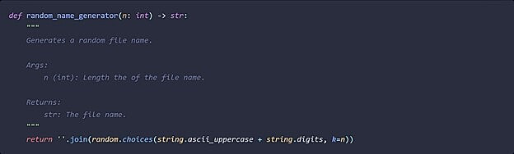

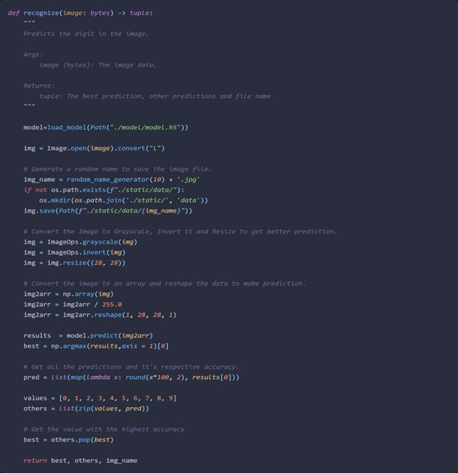

HOME PAGE (HTML)

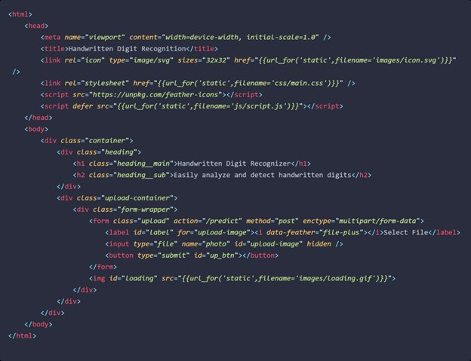

HOME PAGE (CSS)

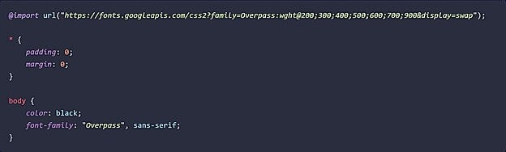

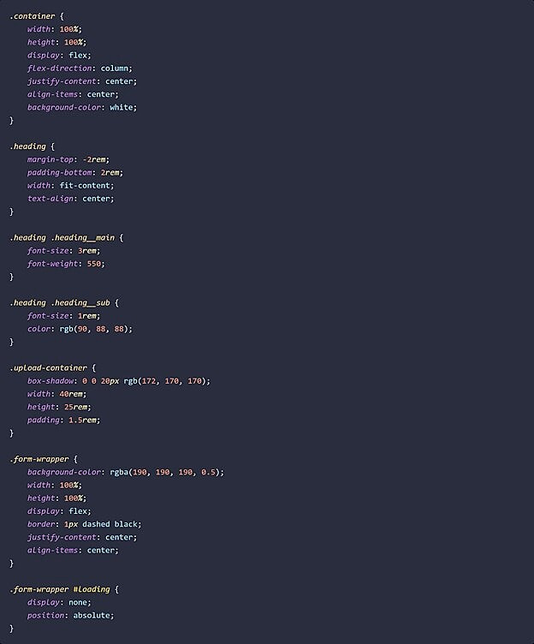

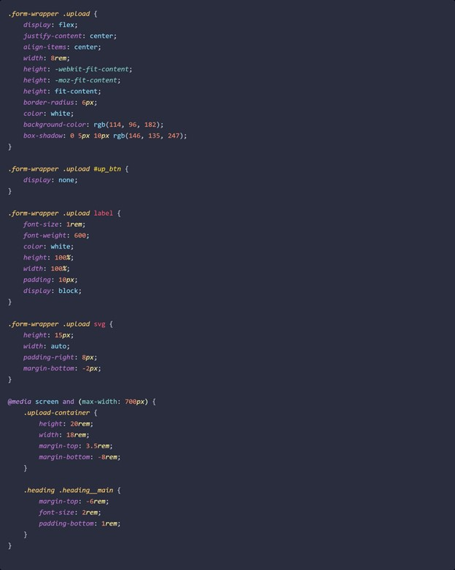

HOME PAGE (JS)



PREDICT PAGE (HTML)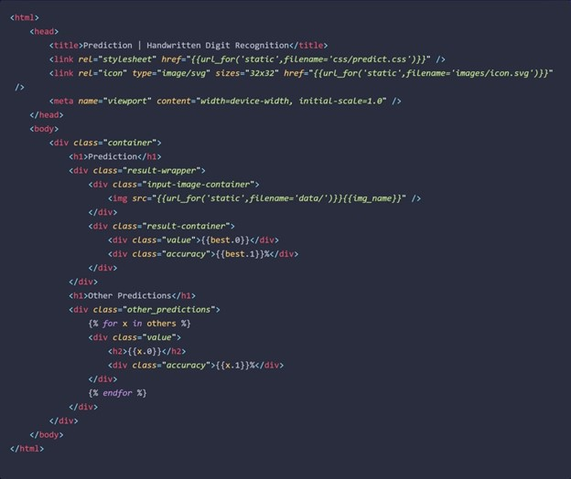

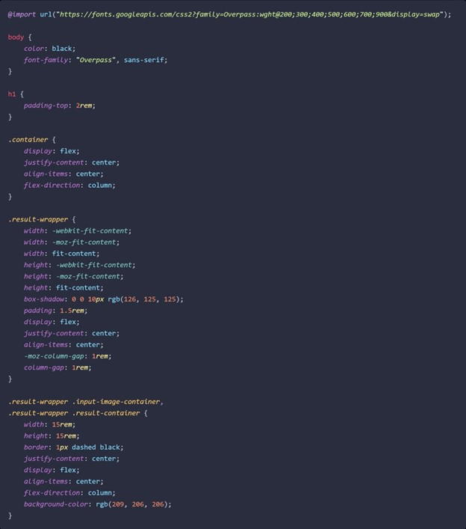

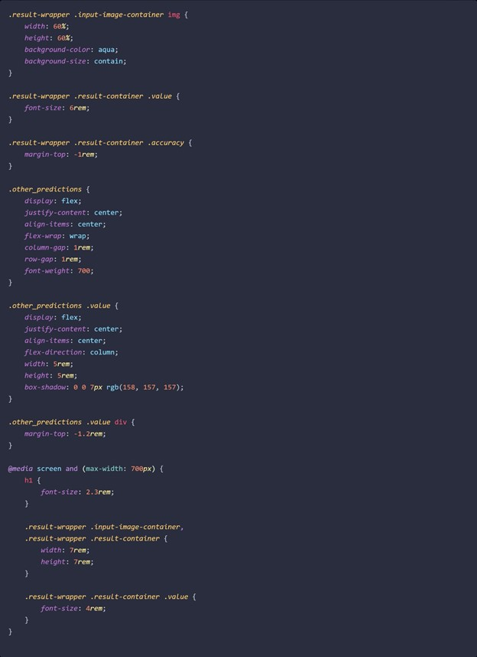

**GITHUB** **LINK :**

https://github.com/IBM-EPBL/IBM-Project-24544-1659944340